R and Python Living in Harmony
Philippe De Brouwer
22/03/2021

Simply mix text and R-code
The data-frame mtcars has the following columns: mpg, cyl, disp, hp, drat, wt, qsec, vs, am, gear, carb.
Here are the first rows and columns:
## mpg cyl disp hp drat wt
## Mazda RX4 21.0 6 160 110 3.90 2.620
## Mazda RX4 Wag 21.0 6 160 110 3.90 2.875
## Datsun 710 22.8 4 108 93 3.85 2.320
## Hornet 4 Drive 21.4 6 258 110 3.08 3.215
And here is a plot:
ggplot(mtcars, aes(x = wt, y = mpg, colour = cyl, size = hp)) +
geom_point() +
geom_smooth()
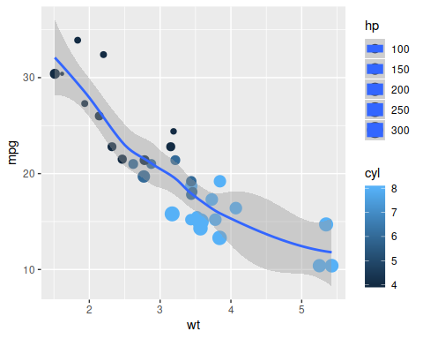
A plot generated by R on R-data.

Run Python in R and use the R-objects
print("This is printed by Python.")
## This is printed by Python.
Note that we can access all R-variables in the object ‘r’. The following code fragments uses the object df from R:
mpg_py = r.df['mpg']
print(mpg_py)
## Mazda RX4 21.0
## Mazda RX4 Wag 21.0
## Datsun 710 22.8
## Hornet 4 Drive 21.4
## Hornet Sportabout 18.7
## Valiant 18.1
## Duster 360 14.3
## Merc 240D 24.4
## Merc 230 22.8
## Merc 280 19.2
## Merc 280C 17.8
## Merc 450SE 16.4
## Merc 450SL 17.3
## Merc 450SLC 15.2
## Cadillac Fleetwood 10.4
## Lincoln Continental 10.4
## Chrysler Imperial 14.7
## Fiat 128 32.4
## Honda Civic 30.4
## Toyota Corolla 33.9
## Toyota Corona 21.5
## Dodge Challenger 15.5
## AMC Javelin 15.2
## Camaro Z28 13.3
## Pontiac Firebird 19.2
## Fiat X1-9 27.3
## Porsche 914-2 26.0
## Lotus Europa 30.4
## Ford Pantera L 15.8
## Ferrari Dino 19.7
## Maserati Bora 15.0
## Volvo 142E 21.4
## Name: mpg, dtype: float64
def averageOfList(num):
sumOfNumbers = 0
for t in num:
sumOfNumbers = sumOfNumbers + t
avg = sumOfNumbers / len(num)
avg = round(avg, 2)
return avg
print("The average of MPG is:", averageOfList(mpg_py))
## The average of MPG is: 20.09

Print something in Python
mpg_py.plot.hist(grid=True, bins=20, rwidth=0.9,
color='#607c8e')
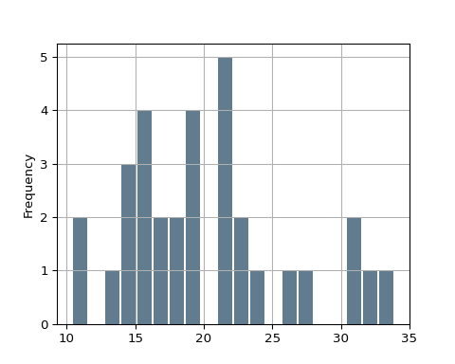

Use the Python objects in R
library(ggplot2)
library(tidyverse)
tbl <- tibble(mpg = py$mpg_py)
ggplot(tbl, aes(y = mpg)) + geom_boxplot(fill="khaki3")
