Ch. 36 Interactive Apps
by Philippe De Brouwer

Introduction to Shiny

Remember the static dashboard
It can be found here: http://www.de-brouwer.com/publications/r-book/shiny_examples.html
(see title “2. A simplified version of the Covid Dashboard with FlexDashBoard”)
Remember the button [Source Code] in the upper right corner.
We will re-use this code in the app

Build a skeleton application
In RStudio: file → New File → Shiny Web App … → fill out the form (use a one-file app), save it and run the app
Running the app: [Run App] in the file level menu
The app is fully working, but does not look like want it to look, nor is the content correct.

Study the skeleton application and note
- The library shiny is loaded
- the main structure is as follows:
  - user interface (“ui”)
  - and server function (“server”)
  - the function shinyApp(ui = ui, server = server) starts the application and uses both functions
The app has one input: the slider level and adapts the number of bins in the histogram accordingly
This number is taken from the function sliderinput(“bins”, …) in the ui. The first parameter of sliderinput() is the name of the variable tha appears in input$bins (in the server, function)
The function renderPlot() will keep track of any variables in it changing and update when that happens. That function in its turn provides a variable output$distplot … which is pasted on the screen via plotOutput(“distPlot”) in the ui.

Get started by libraries and data
- Copy the lines 16 to 47 from the static dashboard: this will give you the data. Save this in a file global.R and save it in the same directory as app.R
- load this file in the app.R (with the source() function)
- add a few global constants (after loading global.R):
  - gc_raw_data <- get_data()
  - gc_dts_countries <- get_dts_countries(gc_raw_data)
  - gc_countries <- c('ALL', unique(gc_dts_countries$Country))
- If you work from within HSBC, you might try to replace the first line with:
gc_raw_data <- read_csv("http://de-brouwer.com/assets/r-book/covid_data.csv")
- replace the slider-bar by a drop-down list that has all the countries, so we can select a country. You will need the function selectInput: selectInput('sel_country', "select country", gc_countries, selected = NULL, multiple = FALSE, selectize = TRUE, width = NULL, size = NULL)
- replace the output$distPlot with one value box:
  - to get a reactive value box, you will need renderValueBox() (provided by flexdashboard)
  - a function to get that number from the selected country. For example add get_last_numbers and get_dts_country to the global.R file:
# Get the data timeset for one country
get_dts_country <- function(d, theCountry = 'ALL') {
if (theCountry == 'ALL') {
d1 <- d %>%
group_by(Date) %>%
summarise(sum(Confirmed, na.rm = TRUE), sum(Recovered, na.rm = TRUE),sum(Deaths, na.rm = TRUE), sum(Sick, na.rm = TRUE))
colnames(d1) <- c('Date', 'Confirmed', 'Recovered', 'Deaths', 'Sick')
} else {
d1 <- d %>% filter(Country == theCountry)
}
as.data.frame(d1) # to make the grouping permanent
}
# get_last_numbers
# returns the last value of the time series
get_last_numbers <- function(d, theCountry = 'ALL') {
d1 <- get_dts_country(d = d, theCountry = theCountry)
# remove date and country name so we can use arithmetic on the whole vector:
if (theCountry != 'ALL') d1 <- d1[,-2]
as.vector(d1[d1$Date == max(d1$Date),]) # data at last midnight
}
  - The output variable in the server function can be:
output$infected_box <- renderValueBox({
x <- get_last_numbers(d = gc_dts_countries, theCountry = input$sel_country)
x_frm <- format(x$Confirmed, big.mark = " ", scientific = FALSE)
valueBox( x_frm, "Confirmed", icon = icon("ambulance"), color = "purple")
})
  - in mainPanel() of the ui, we put then: valueBoxOutput("infected_box", width = 6)
When we run the app, it will look as follows:

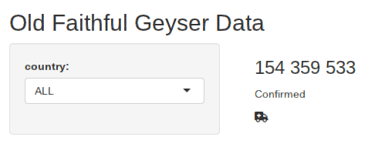

Add the layout
While we have loaded the library shinyDashboard, we did not really use it yet.
1. replace the ui from a Bootstrap page (fluidPage()) to a dashboardPage(). Don’t forget to add skin, dashboardHeaders, and replace sidebar with dahsboardSidebar, as well as mainPanel with dashboardBody()

The layout will now be as follows:
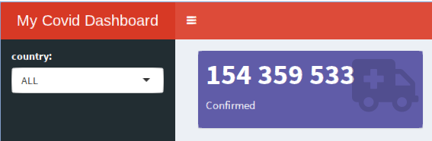

Add more menu items, pages and content.

The menu
dashboardSidebar(
sidebarMenu(# nice layout + indication which one is active
# Header:
h4('Selected Country'),

# selct the country input:
selectInput('sel_country',
"country:",
gc_countries,
selected = NULL,
multiple = FALSE,
selectize = TRUE,
width = "100%",
size = NULL),

# a separator:
hr(),

# the menu items:
menuItem("Dashboard", tabName = "dashboard", icon = icon("th")),
menuItem("Forecast", tabName = "forecast", icon = icon("sun"))

) #close sidebarmenu()
), # close DashboardSidebar

You can test this via [Run App]: it should look good but won’t work yet.

The framework for the dashboard body
We need to connect each tabName to further content in the dashboardBody(). This can be done by adding a tabItem with the corresponding name (for example wrapped in fluidRow()) – this creates rows that turn into columns in narrower screens.
Here is a minimal example:
dashboardBody(
fluidRow(style='padding:5px;',
tabItems(
tabItem("dashboard",
h1('The Dashboard'),
valueBoxOutput("infected_box", width = 6)
),
tabItem("forecast",
h1('The Forecast'),
HTML('<h1>TBA</h1>') # we will add this later
) # close tabItem
) # close tabItems
) # close fluidRow
) # close dashboardBody()
) # close dashboardPage

Again, we can test at this point if it all works and how it looks like.

The content for the dashboard body
Here we will copy and modify the content that was produced in the static dashboard and make it work for the selection of the country in the left menu and eventually add interactivity. We will develop this code per tabItem. First we focus on the main dashboard. Now it is the following block.
tabItem("dashboard",
h1('The Dashboard'),
valueBoxOutput("infected_box", width = 6)
),
In this section, we will include the code from the dashboard that looks as follows in the passive dashboard that we created with flexDashboard (lines 62 to 111). We need to modify this because we don’t work with R Markdown.
We need to add the remaining boxes and decide how to order them on the screen. Maybe we can use 3 rows of 2 elements.
This will happen automatically if we provide the correct width (since it follows Bootstrap’s 12 column model.
Remember, that to do this, we need in the ui:
valueBoxOutput("infected_box", width = 6)
and in the server function the corresponding:
output$infected_box <- renderValueBox({
x <- get_last_numbers(d = gc_dts_countries, theCountry = input$sel_country)
x_frm <- format(x$Confirmed, big.mark = " ", scientific = FALSE)
valueBox( x_frm, "Confirmed", icon = icon("ambulance"), color = "purple")
})
We will repeat this process for the other boxes:
first for the ui:
tabItem("dashboard",
h1('The Dashboard'),
column(6,
valueBoxOutput("infected_box", width = 12),
valueBoxOutput("sick_box", width = 12),
gaugeOutput("sick_gauge", width = "200px", height = "200px")
),
column(6,
valueBoxOutput("recovered_box", width = 12),
valueBoxOutput("death_box", width = 12),
gaugeOutput("death_gauge", width = "200px", height = "200px")
)
),
then for the server function:
# We extract only once the last numbers of the selected country:
last_numbers <- reactive(
get_last_numbers(d = gc_dts_countries, theCountry = input$sel_country)
)

# The confirmed cases
# !! note we need renderValueBox from shinydashboard and not from flexdashboard
output$infected_box <- shinydashboard::renderValueBox({
x_frm <- format(last_numbers()$Confirmed, big.mark = " ", scientific = FALSE)
valueBox( x_frm, "Confirmed", icon = icon("ambulance"), color = "purple")
})

# Number of people still sick
output$sick_box <- renderValueBox({
x_frm <- format(last_numbers()$Sick, big.mark = " ", scientific = FALSE)
valueBox(x_frm, "Sick", icon = icon("procedures"), color = "yellow")
})

# The recovered cases
output$recovered_box <- renderValueBox({
x_frm <- format(last_numbers()$Recovered, big.mark = " ", scientific = FALSE)
valueBox(x_frm, "Recovered", icon = icon("smile"), color = "green")
})

# Deaths
output$death_box <- renderValueBox({
x_frm <- format(last_numbers()$Deaths, big.mark = " ", scientific = FALSE)
valueBox(x_frm, "Deaths", icon = icon("skull"), color = "maroon")
})

# The gauge with the sick rate (how much percent is still sick?)
output$sick_gauge <- renderGauge({
rate <- round(last_numbers()$Sick / last_numbers()$Confirmed, 2)
gauge(rate, min = 0, max = 1, symbol = '%', gaugeSectors(
success = c(0, .39), warning = c(.40, .79), danger = c(.80, .100)
))
})
# The gauge with the death rate
output$death_gauge <- renderGauge({
rate <- round(last_numbers()$Deaths / last_numbers()$Confirmed, 2)
gauge(rate, min = 0, max = .1, symbol = '%', gaugeSectors(
success = c(0, .02), warning = c(.021, .05), danger = c(.051, .100)
))
})
At this point, we can test again, and it should look as follows:
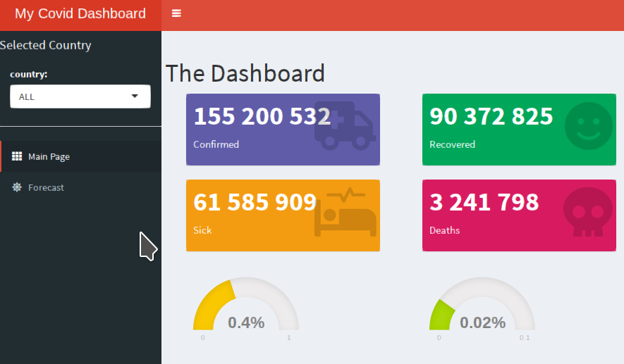

The content for the forecast tab-item
Here we will expand the following:
tabItem("forecast",
h1('The Forecast'),
HTML('<h1>TBA</h1>') # we will add this later
) # close tabItem
and add the exponential regression together with user selection of data and number of days to forecast (on top of the over-arching country selection)
To keep the server function clean, we will add the functionality in the global.R file, but that

# ----------------------------------
add_forecast <- function(d, # timeseries for the given country
theRow, # e.g Sick, Confirmed, etc.
dte_start, # starting date for the data to use
f_nbrDays = 14 # number of days to forecast
) {

# prepare the data
dd <- d %>% filter(Date > dte_start)
x <- dd$Date
y <- dd[[theRow]]
n <- 1:nrow(dd)
N <- max(n)
dd <- cbind(dd, n, y) # we add a column y (universal name for the dependent variable)

# find good starting values
theta.0 <- min(y) * 0.5
model.0 <- lm (log(y - theta.0) ~ n)
alpha.0 <- exp(coef(model.0)[1])
beta.0 <- coef(model.0)[2]
starts <- list(alpha = alpha.0, beta = beta.0, theta = theta.0)

model <- NULL
try({
model <- nls(y ~ alpha * exp(beta * n) + theta,
data = dd, start = starts,
#algorithm = 'port',
nls.control(maxiter = 100, minFactor = 0.000002, tol = 1e-03))
}) #try

if(f_nbrDays > 0) {
df_frcst <- tibble(
Date = as_date((max(dd$Date) + days(1)):(max(dd$Date) + days(f_nbrDays - 1))),
y = NA, #NOTE: we use y instead of Sick, Confirmed, etc.
n = (N + 1):(N + f_nbrDays - 1)
)
dd <- bind_rows(dd, df_frcst)
}
#df <- df %>% dplyr::mutate(Forecast = predict(model, newdata = df)) ## fails ... Error: Column `Forecast` must be length 1 (the group size), not 74
dd$Forecast <- predict(model, newdata = dd)
return(dd)
}

# ----- return the plotly plot
plot_forecast <- function(dd, theRow) {
plot_ly(dd, x = ~Date, y = ~y, type = 'scatter', name = "Daily people sick",
mode = 'markers', marker = list(size=8)) %>%
add_trace(x = ~Date, y = ~Forecast,
mode = 'lines', type = 'scatter', name ='Model Estimate', line = list(width = 3), marker = list(size=1)) %>%
layout(
title = paste("Forecast for:", theRow),
xaxis = list(title = "Date"),
yaxis = list(title = "Number of People"),
#autosize = TRUE,
showlegend = TRUE)
}
We also prepare the output in the ui, and replace the tablItem:
tabItem("forecast",
h1('The Forecast'),
fluidRow(
shinydashboard::box( #input of extra variables
title = "Make your choice",
selectInput("sel_data",
"Data:",
gc_impact_types),
dateInput('dte_start', 'Use data from:',
value = gc_first_date,
min = gc_first_date, max = gc_last_date,
format = "yyyy-mm-dd", startview = "month",
weekstart = 0, language = "en" ),
sliderInput("f_nbrDays", "Number of days to forecast:",
value = 14, #the defa
min = 1, max = 90,
step = 1, round = TRUE)

)
),
fluidRow(
shinydashboard::box( #input of extra variables
width = 12, # default is 6
title = "The forecast",
plotlyOutput('plot_frct',
width = "100%", height = "350px", inline = FALSE
)
)
),
) # close tabItem
and prepare the output in the server function (while using the functions of global.R and matching the input generated. There we add the following:
# the data for the selected country:
d <- reactive(get_dts_country(gc_dts_countries, input$sel_country))

# the forecast plot
dd <- reactive(add_forecast(d(), # timeseries for the given country
input$sel_data, # e.g Sick, Confirmed, etc.
input$dte_start, # starting date for the data to use
input$f_nbrDays # number of days to forecast
))

# prepare the plot for output
output$plot_frct <- renderPlotly(plot_forecast(dd(), input$sel_data))
The second tab will now look as follows:
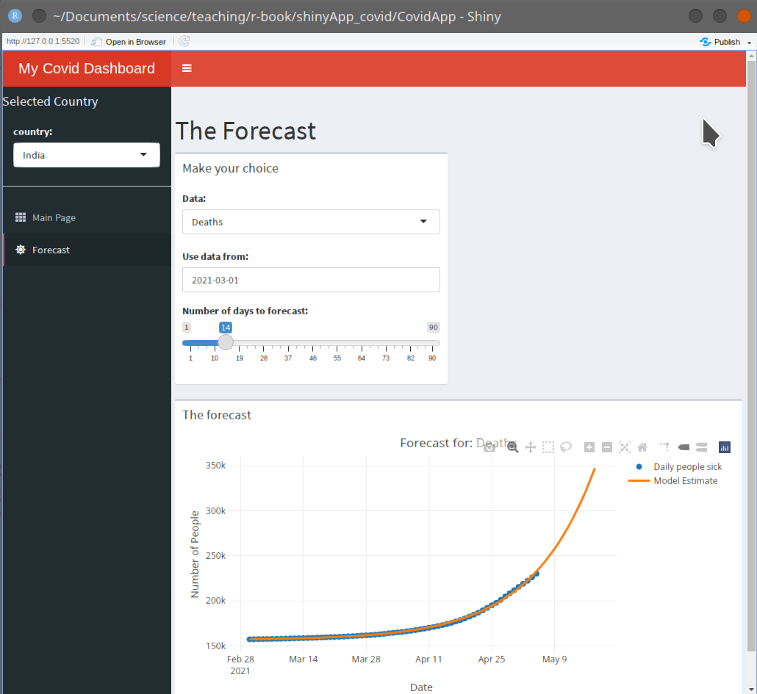

Shiny with R Markdown
In Rstudio select
[File] → [New File] → [Rmarkdown …] → select “Shiny” and follow the instructions
Study the file and convert the previous app into an R-Markdown shiny app.

